High Level Diagrams

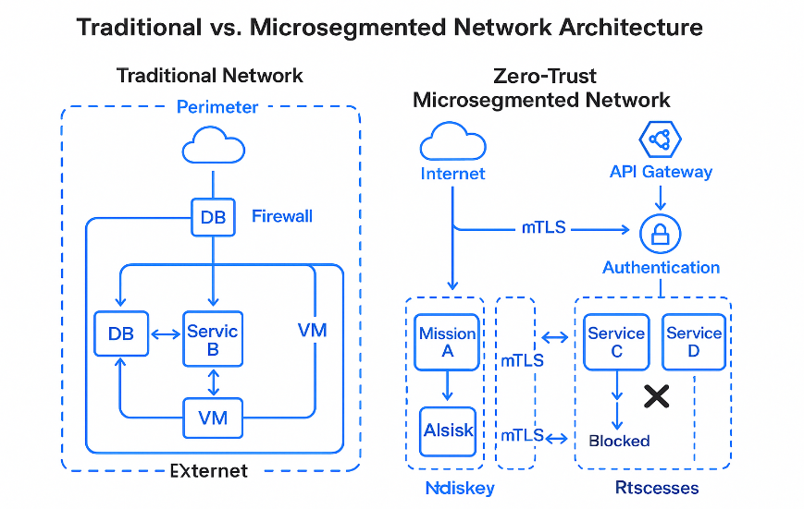

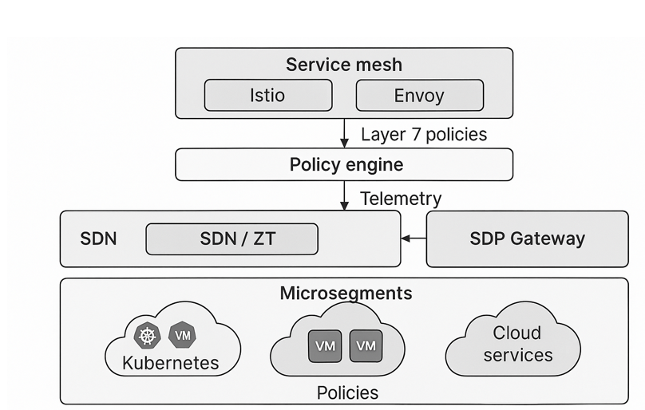
Integrated Zero Trust Microsegmentation Framework for Hybrid and Multi- Cloud East-west Traffic Control

